# CS 255 System Design Document Template

## UML Diagrams

### UML Use Case Diagram

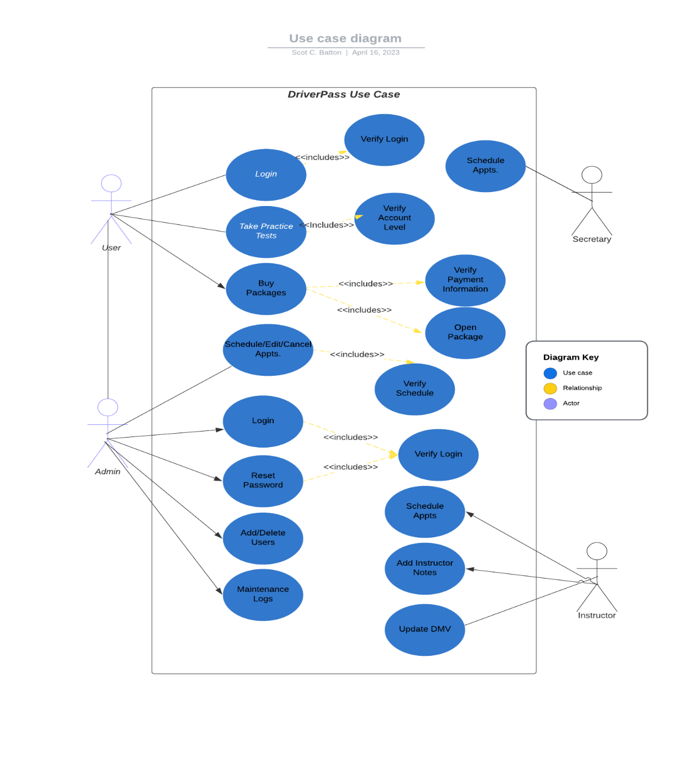

### UML Activity Diagrams

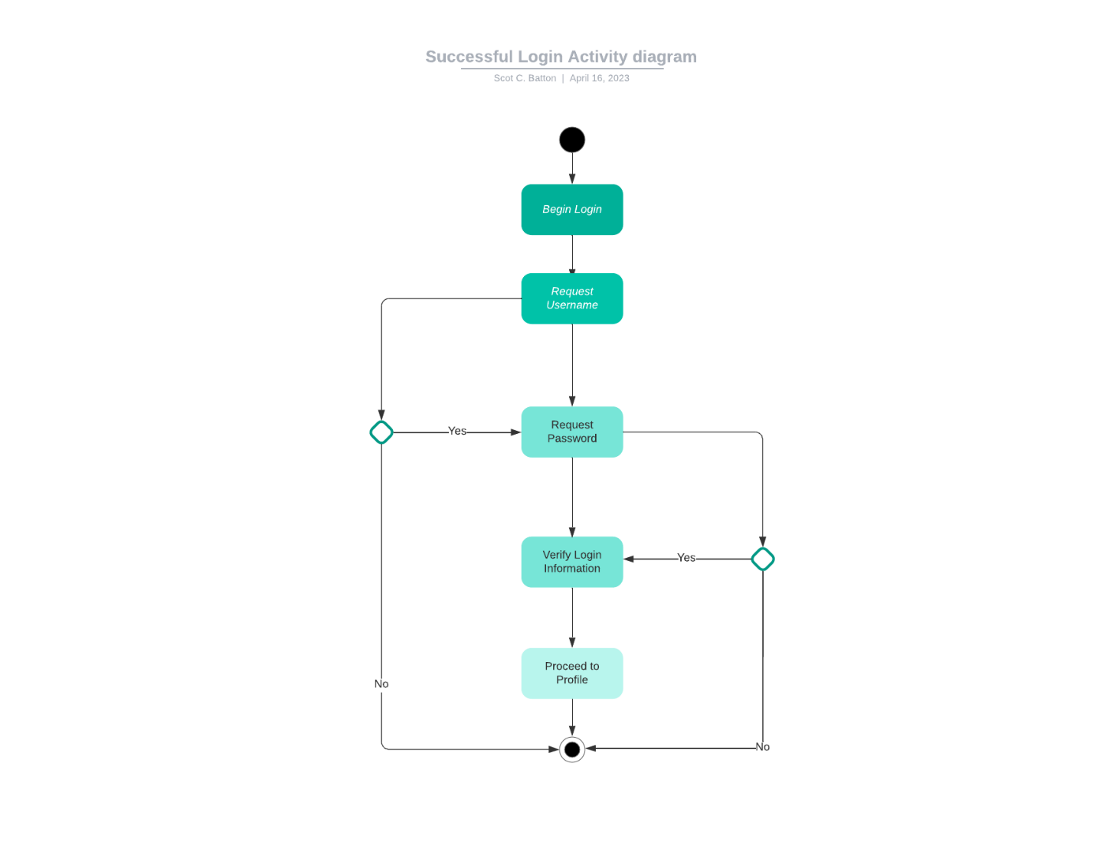

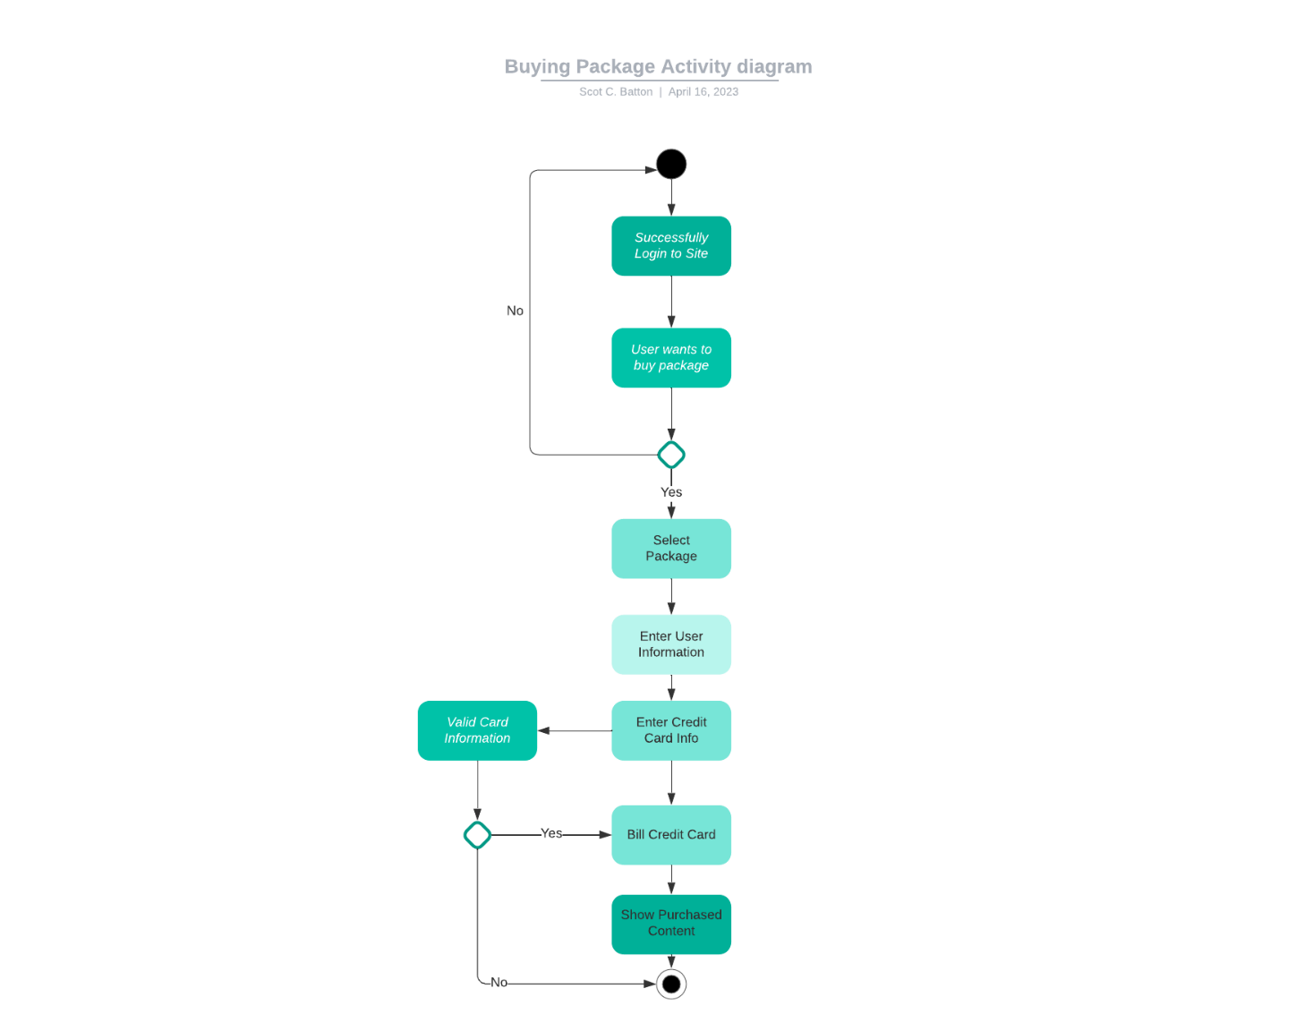

### UML Sequence Diagram

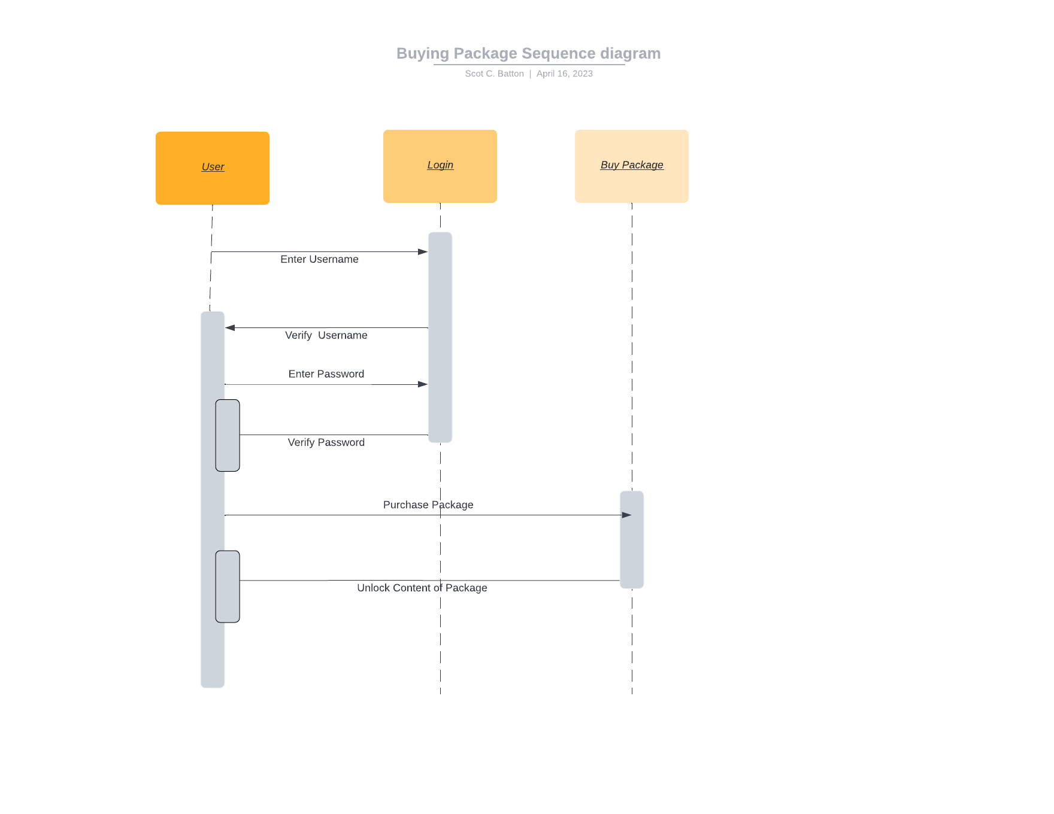

### UML Class Diagram

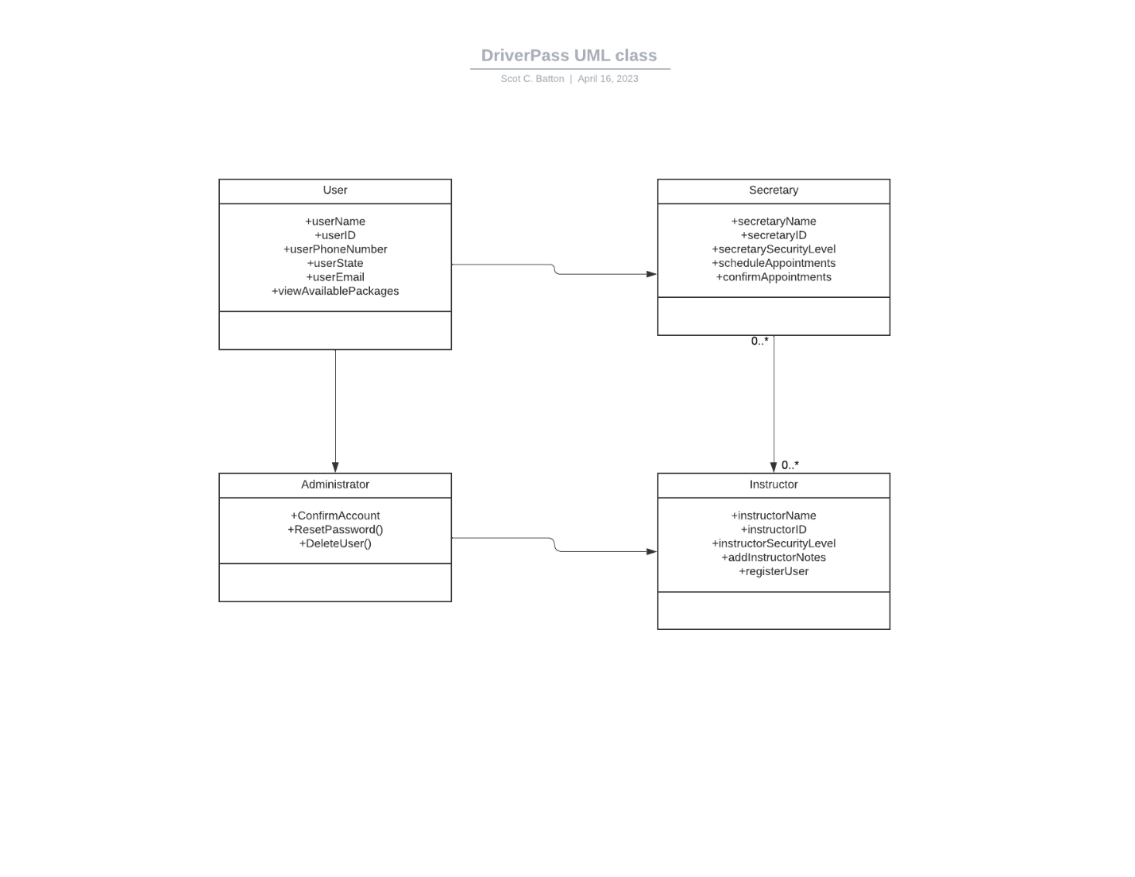

## Technical Requirements

*The system design for DriverPass has a few technical requirements that need to be addressed. The system for DriverPass will be developed utilizing AWS Cloud. The cloud will allow for the immediate distribution and implementation of the site. The Cloud will allow for more scalability of the system and remove the need for in-house servers. This type of storage and performance will allow the system to be more efficient and cost less for DriverPass. The system needs to be available on desktop and on mobile devices. The Linux OS works with the AWS services and with mobile devices. This will allow interoperability between systems. The system will require multiple computers in house to provide training for those who come in person. The system will also need computers, scanners, and payment systems to allow for smooth system flow.*